Day 46 – Half Subtractor Using MUX

Introduction: Implemented a Half Subtractor using MUX.

Design: Difference: D = A ⊕ B Borrow: Bo = A'B
The Half Subtractor was implemented using 2:1 MUX and 4:1 MUX.

1. Half Subtractor Using 2:1 MUX
Difference: I0 = A, I1 = ~A, S = B Borrow: I0 = 0, I1 = ~A, S = B

Design Code:

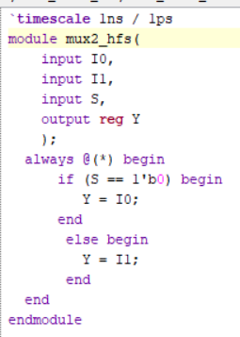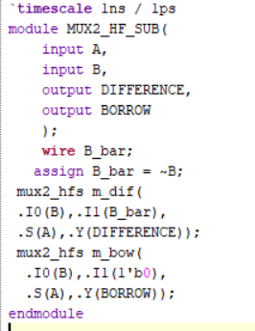

Testbench:

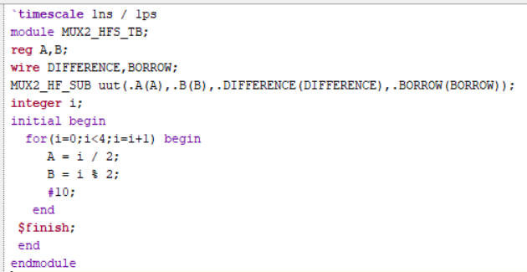

Waveform:

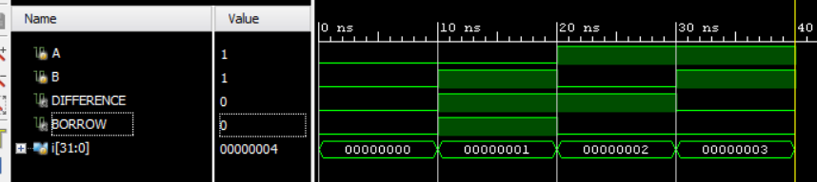

Schematic:

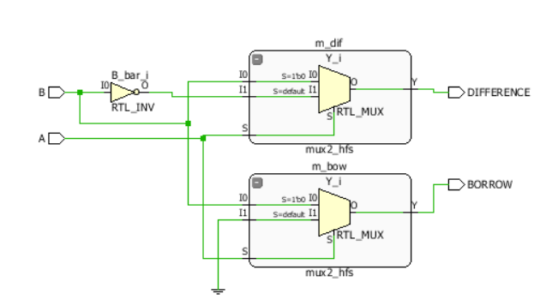

2. Half Subtractor Using 4:1 MUX

Design: Difference: I0 = 0, I1 = 1, I2 = 1, I3 = 0, S1 = A, S0 = B

Borrow: I0 = 0, I1 = 1, I2 = 0, I3 = 0, S1 = A, S0 = B

Design Code:

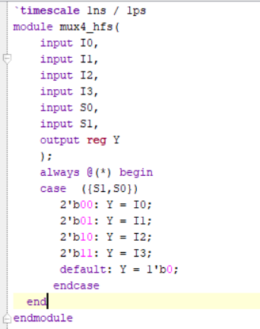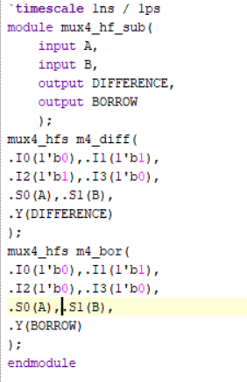

Testbench:

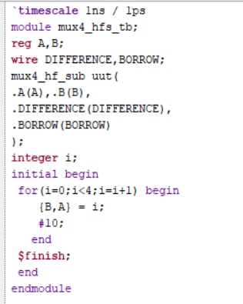

Waveform:

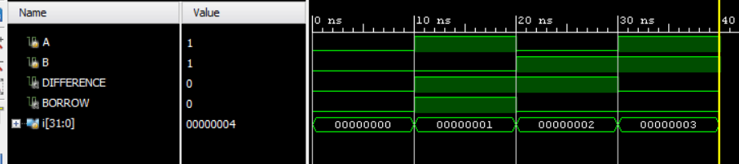

Schematic:

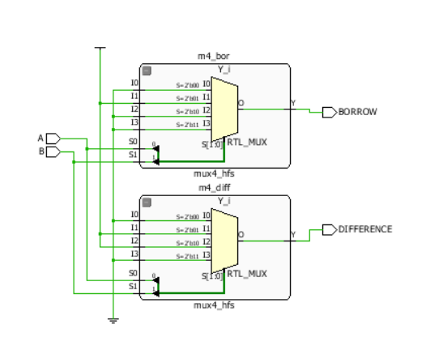

Observation
- Half Subtractor was successfully implemented using 2:1 and 4:1 MUXes.
- Difference output performs XOR operation.
- Borrow output performs A'B operation.
- The waveform verifies the expected outputs.
- This helps understand how arithmetic circuits can be implemented using MUXes.

#PHANEENDRA.SINGUDASU

